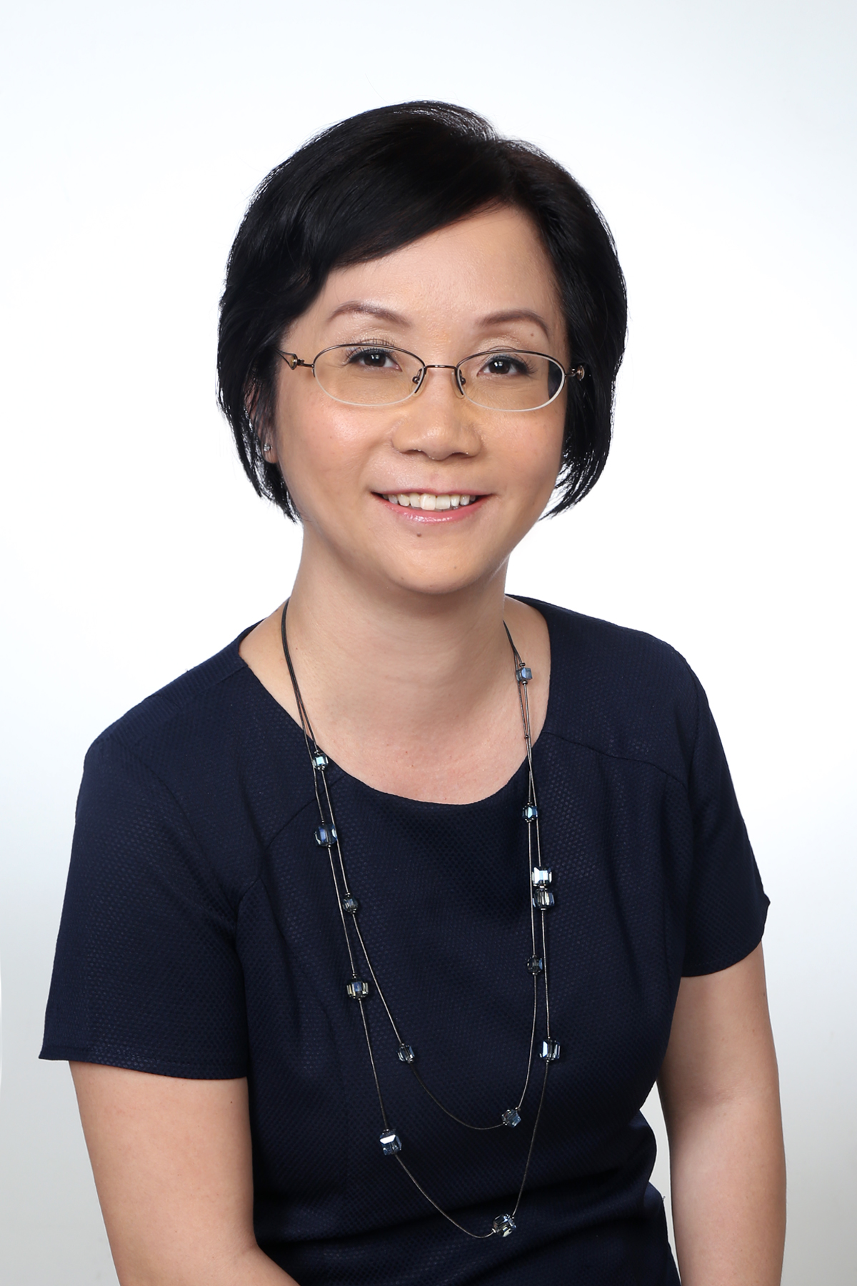

Wee Lee Yen, Jasmine

Email: jasweelee@yahoo.com.sg
Contact: 9062 3874

Summary of Qualifications and Experience

Over 21 years of experience in financial accounting, management reporting, budgeting, system implementation and process improvement with an investment house, real estate companies, including a hospitality company, a financial institution and a public healthcare provider.

      - Developed Finance Manual for company’s finance function in both private sector and public sector settings.
      - Sourced for and acquired various aspects of grants and funding from Ministry.
      - Successfully arranged for bank refinancing of Japan assets, including completion of legal documentation.
      - Appointed Finance Manager for a US$400 million Private Real Estate Fund that was launched.
      - Streamlined company’s processes by successfully launching a new financial system for company.
      - Effectively contributed to the successful launch of Singapore’s first Islamic Private Real Estate Fund.

Professional Experience

SilverNeedle Hospitality Pte Ltd
(SilverNeedle Hospitality is an integrated hospitality, investment management and development company with a key focus on Australia, New Zealand, Thailand, Laos and Sri Lanka. The company currently manages over 55 managed and licenced hotels and accounts for more than 3,500 keys in the Asia Pacific.)

Assistant Vice President Jan 2016 to Feb 2017
Group Financial Controller Jan 2014 to Dec 2015

- Oversee the finance section with a staff strength of 7, spanning across Singapore, Australia and Thailand.
- Involve in financial and operational aspects of the business.
- Responsible for consolidation of the group.
- Review regional offices’ financials.
- Update Senior Management and Board on group’s performance on a monthly basis.
- Manage the external annual audit exercise.
- Look into the structuring of new acquisitions with the Investment Team.
- Support financing activities for new investments and refinancing of existing projects. Finalised senior debt of AUD73 mil for a project in Australia.
- Arranged for USD19.5 mil bank guarantee facility for the group.
- Handled refinancing of USD19.5 mil bank guarantee facility for the group.
- Drive financial systems implementation. Launched Microsoft Dynamics AX in Thailand and Australia.
- Act as company secretary of all Singapore entities and holding company.
- Responsible for reviewing of all legal contracts at group level.

JurongHealth Services Pte Ltd
(JurongHealth Services is the public healthcare cluster of the West. The cluster comprises a 700-bed acute hospital and a 400-bed community hospital. The hospitals are the first hospitals in Singapore to be designed and built from the ground up to complement each other and better cater for patient’s needs.)

Financial Controller May 2011 to Jan 2014

- Ran the finance department with a staff strength of 18.
- Managed accounts of the hospital and prepared updates of financial performance to Senior Management and Board.
- Reviewed existing processes and streamlined and refined policies and procedures.
- Drove the budget process.
- Involved as a key representative in the evaluation and selection of the hospital’s electronic medical records system for the purposes of enabling patients having one medical record across medical facilities.
- Liaised closely with Ministry of Health and MOH Holdings and obtained funding for the construction of the hospitals, equipment procurement and operations of the hospitals.

Alpha Investment Partners Limited
(Alpha Investment Partners is a real estate investment advisory firm which is Keppel Land’s real estate fund management arm. The target markets are Singapore, Japan, South Korea and Hong Kong.)

Senior Finance Manager Sep 2009 to January 2011

- In charge of more than 5 private Real Estate Funds teams.
- Involved in financial, operational aspects and consolidation of the Funds’ performance.
- Provided Board and Investors with quarterly Funds’ performance.
- Worked closely with Investment Team and Asset Management Team on the budget process.
- Looked into the structuring of new acquisitions with the Investment Team.
- Arranged bank financing for new investments and refinancing of existing deals, both in Japan and Hong Kong.
- Reviewed loan documentation for financing arrangements.

Temasek Holdings (Private) Limited
(Temasek Holdings is an investment company based in Singapore with an investment portfolio size of $266 billion as at 31 March 2015.)

Associate Director, Finance Oct 2007 to August 2009

- Responsible for accounts of holding company, 6 overseas offices and investment holding companies.
- Oversaw the centralized Accounts Payable function.
- Assessed investment opportunities.
- In charge of group management consolidation and reporting.
- Coordinated the budget process with investment teams and other business clusters.
- Involved in the upgrade of SAP system and implementation of consolidation system.

Ascendas Pte Ltd
(Ascendas is Asia’s leading provider of business space solutions with clientele in 26 cities spread across 10 countries, including Singapore, China, India, Malaysia, South Korea and Vietnam.)

Senior Manager, Group Finance Jun 2006 to Sep 2007

- Oversaw the International Operations Team with a staff strength of 6.
- Managed accounts of investment holding companies, fund management companies, overseas subsidiaries and investee companies.
- Reviewed consolidation of the international operations group with more than 30 companies and prepare quarterly reports for head office.
- Worked closely with the Fund Business Team and Asset Management Team in the structuring of funds and new acquisitions and budget.
- Appointed Finance Manager for a US$400 million Private Real Estate Fund that was launched.
- Identified and implemented process improvements for the finance department.
- Implemented a new financial system (YARDI) for the company.

CapitaLand Financial Limited
(CapitaLand Financial is one of Asia’s largest real estate company, with a diversified real estate portfolio, including integrated developments, shopping malls, serviced residences and offices.)

Manager, Finance Apr 2004 to May 2006

- Reviewed the holding company accounts, accounts of a group of companies in the fund management area of business, overseas subsidiaries accounts and accounts of the Islamic Fund.
- Performed consolidation of the group and prepare information for quarterly announcement and management information.
- Prepared forecast and budget numbers.
- Prepared EVA computation.
- Participated in the evaluation and selection of a new financial system (SAP) for the company and was main GL lead for setting up chart of accounts.

Hong Leong Finance Limited
(Hong Leong Finance is the largest finance company in Singapore.)

Treasury Officer Jan 1998 to Dec 2000
Deputy Manager, Accounts and Treasury Jan 2000 to Mar 2004

Treasury
- Appointed as Treasury Officer in 1998, responsible for treasury department with a staff strength of 3.
- Handled a funds position of above $500 Mil and investment portfolio of above $300 Mil.
- Updated departmental heads on interest rate trends, economic outlook and strategies for our deposit position.
- Kept in close contact with bankers to incorporate new banking arrangements.
Accounting
- Promoted to Deputy Manager, Accounts and Treasury in 2000.
- Took on Accounts function with a staff strength of 5.
- Prepared monthly reports for submission to Monetary Authority of Singapore (MAS).
- Involved in consolidation of the group.
- Prepared and analysed management and financial accounts for senior management.
- Ensured tax compliance of the group.
Setting Up and Upgrading of Systems
- Role expanded in 2001 to include system implementation and system training.

Hong Leong Finance Limited
(Hong Leong Finance is the largest finance company in Singapore.)

Internal Auditor Aug 1994 to Jul 1996

- Conducted audit work to ensure compliance with operational procedures and perform credit review of hire purchase dealers.

Education

- Masters of Science (Business and Management), Strathclyde Graduate Business School, Glasgow, UK (Sept 1996~Dec 1997).
- Bachelor of Accountancy, Nanyang Technological University (1991~1994).

Professional Membership

Institute of Singapore Chartered Accountants (ISCA)

